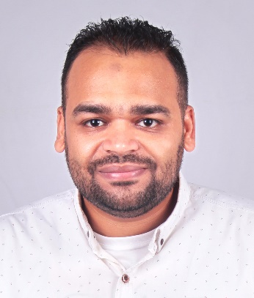
Ahmed Abd El-Shaheed
Senior Graphic designer
https://shaheeddesign.com/
https://www.behance.net/ahmedshahe970b
https://www.linkedin.com/in/ahmed-abd-el-shaheed-61337a101/
About Me

A Highly experienced, skilled and professional graphic designer with over 15 years of experience.
I worked in many companies and institutions, participating in projects of different complexities. Creative skills in transforming ideas into images, such as Branding, Social Media designs and motion graphic videos.
Personal Information

Name: Ahmed Mahmoud Ahmed Abd El shaheed
Nationality: Egyptian
Date of birth: 26/1/1987
Military service: Exempted
Marital Status: married
Email: ahmedshaheed515@gmail.com
Phone Number: +2011 13 615 914 - +2010 10 580 782
Adress: Haram Giza
Education

Degree: Bachelor of Arts
Department: History
University: Helwan University
Grade: Good
Graduation Year: 2008
Work Experience

- Senior Graphic Designer
- -(freelancer) July 2020 – untii now
- Know the details of clients' projects
- -Share the concept of the idea and communicate it to the implementation team.
- -Follow up the workflow plan, receive the work, and then review
- - Make any technical notes for the entire project
- - designing graphic material, attracting consumers via social media and building high-quality multimedia projects for the customer.
- - create all commercial visual products such as all social media posts, logo, offline advertisement, company stationery etc.
- Senior Graphic Designer
- (TGF GROUP) July 2020 - July 2022
-Know the details of clients' projects
-Share the concept of the idea and communicate it to the implementation team.
-Follow up the workflow plan, receive the work, and then review
- Make any technical notes for the entire project
- designing graphic material, attracting consumers via social media and building high-quality multimedia projects for the customer.
- create all commercial visual products such as all social media posts, logo, offline advertisement, company stationery etc.

- Senior Graphic Designer
(Secret Agency) Jan 2019 - Jan 2020
- Conceptualizing visuals based on requirements
- Creating Social media designs
- Creating Motion videos & GIF
- Creating Branding & logo designs

- Senior Graphic Designer
(Sahab Advertising Agency) Jan 2018 – Dec 2018
-Responsible for creating and designing all the business needs ideas from
A to Z and Apply Customer's Modifications to Designs

- Senior Graphic Designer
(Al-Wasaq for Information Technology) Jan 2016 – Dec 2017
- Design and execute layouts/marketing assets for homepage features,
landing pages, digital marketing, social media, site banners, packaging,
product labels, newsletters

- Senior Graphic Designer
(Easy2have group) Jan 2013 – Dec 2015
Some of my job duties in the company.
- Branding identities, Logos, Business Cards, Flyers, etc.
- Company’s profile.
- Social Media designs.
- Preparing presentations for design projects including mood boards &working drawings.
- Graphic Designer
(Top one for Advertising) Jan 2012 – Jan 2013
Responsible for producing designs in the printing department from designing packages to pharmaceutical companies and designing book covers, magazines, flyers and small brochures.
- Junior Graphic Designer
(Seven stares For Digital Printing) Jan 2010 - Jan 2012
Worked with designers’ team to gather and define Client requirements, establish scopes, and make the brand direction.to design large billboards for major companies such as Coca-Cola for soft drinks and Pachin for paints. Designing advertising campaigns for football matches in the Egyptian League.
Courses

- English language course at the ministry of defence language institute (model).
- Graphic Diploma (photoshop, illustrator, in design) at El-Ahram newspaper (AMAC).
- Training course in Adobe After Effects (khater academy).
- Training course in Cinema 4 D (Adobe EG Academy).
- International Computer Driving license (ICDL).
Skills

- Adobe Photoshop 90%
- Adobe Illustrator 90%
- Adobe InDesign 85%
- Adobe aftereffect 80%
Personal Skills

- Time management 90%
- Communication 80%
- Creativity 90%
- Athletic 70%
- Energetic 85%
- Team Work 85%
Thank you

