From Concept To Creation

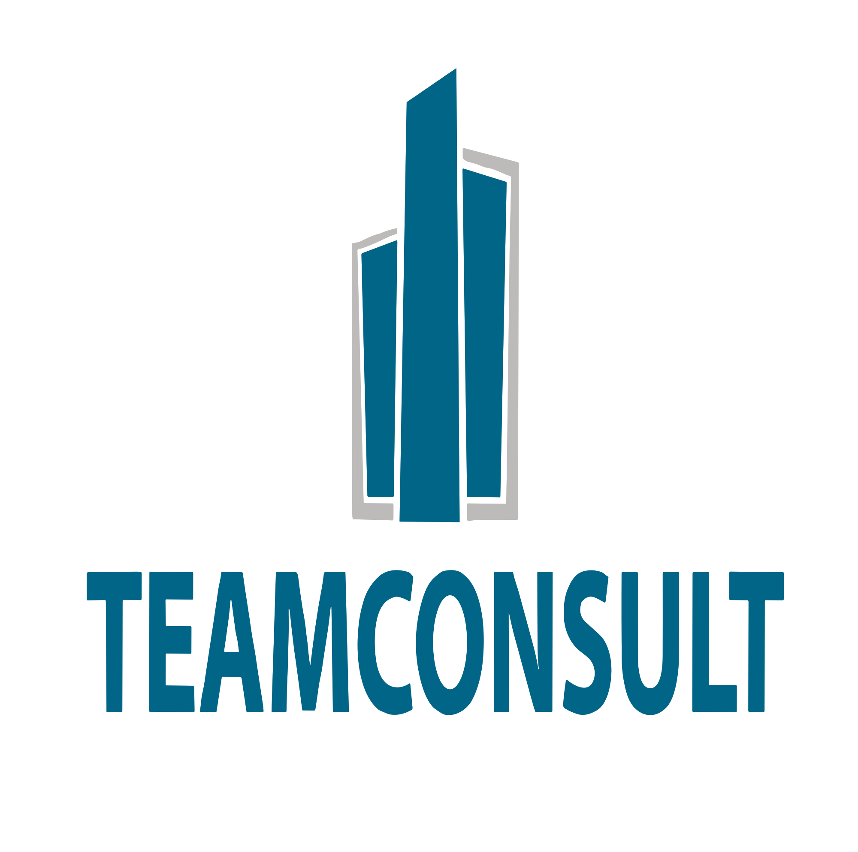
Technical Studies, Enginee

ABOUT US

Founded in 2003, Teamconsult Is a Sudan registered and based professional firm licensed to practice as a general consultation firm.

Teamconsult and its selected staff have proven experience managing distinguished and effective architectural services.
Teamconsult is a home for a group of highly specialized professionals who contribute to the progress of human development our creative minds with design studio create world-class design solutions with deep social and cultural understanding
of communities we design for.

The firm produces broadly contextual, creative responses to both programmatic and economic priorities. We understand our practice of design and delivery to be a single integrated "field", in which programming, function, implementation, engineering, economic performance and cultural impact are not independent consideration but should rather be evaluated and addressed as codependent factors.
We offer full architectural services, including conceptual design, feasibility studies, Land-use plans, assessment reports, community engagement, tender support and construction supervision.
Teamconsult design for the real world. We work within budget, schedule, climate and site constrains to elevate the design.
Our projects are remembered for their unique aesthetic and Livability -

Our Vision
We earn client's confidence through innovative design and sound decisions that are grounded in collaboration and experience. We bring dynamic design teams together to develop exceptional projects for our clients. our unparalleled respectful Knowledge and honest services is prime reason our client choose to continually for business with us.

Our Mission
Our mission is to become a Leading consulting firm in creative design solutions that resolve our client's social, environmental and economic need. Our tradition of decision, professionalism and outstanding customer services is a testament to that mission as we strive each day for excellence in bringing our valued client's ideas to life.

Our values
We rested upon six solid principles that could be described as our core values. Through the decades these have underscored the success of Teamconsult and sustained our unique position as one of the most respected and time-honoured architectural practice. These can be summerised as:

→ Integrity
We stake our reputation and found our relationships on honesty, trust, respect and financial integrity.

→ Design Excellence
We believe in the extraordinary power design to influence the quality of life.

→ Innovation
we challenge the status quo in order to access improved processes and technologies.

→ Collaboration
we take time to listen. We interate in a co-creative process with clients, consultants and contractors.

→ Enhancing Knowledge
we actively seek to drive improvement through our company, our staff and the work that we do.

→ quality in services
We are committed to providing clear, concise and accurate information and advice. We focus on results, and do all we can to achieve the desired out come.

Our clients

We contentiously provided top quality consulting services to wide variety of clients, including governmental units and international agencies as well as private sector clients.

Principal Field of Activities

- Project Management
- Economic and feasibility studies
- Planning and Architecture
- Civil engineering & MEP
- Construction supervision
- Building Evaluation and Assessment
- Environmental Impact Assessment (EIA)

Offices

A creative office design that evolves with time need to be adaptable, flexible and able to change and grow as the needs of the organisation and its employees change.
Our design office philosophy encompasses the principles and concepts that guide the creation of functional and asethetically pleasing work environment.
Teamconsult believes that a well designed office space can serve as a catalyst for creativity, collaboration and overall well-being.

As we believe into design of new office space, we want to share our thoughts on the office design concepts that we believe have greatest positive impact on users.
• Understanding that workplace design significantly affects human behavior.
• Creating productive and comfortable interior atmosphere.
• Creating spaces That can change.
• Using techology wise.
• Balancing different office space.

“Simplicity is the ultimate sophistication.”
Leanardo Da Vinci

“Architecture is reaching out for truth.”
Louis khan

Healthceare
Teamconsult believes that healthcare architectural involves a delicate balance of functionality, safety and patient well being, all within complex regulatory frameworks, making the design process highly specialised. Every decision, from Spatial Layout to material selection can directly influence patients outcomes and operational efficiency. As such, we play a crucial role in shaping environment that foster healing while meeting the stringent demands of modern healthcare delivery.
To create a healthcare space that prioritises the well being of patients and seamless work flow our team will use the following principles to guide building design decision:
• Infection control
• patient mental well being
• operation and safety
• Adaptability
• Sustainability
• Meeting healthcare building regulation
• smart design.

“A great design is a multi-Layered relationship between Human Life and its environment.”
Naoto Fukaswa
Educational

At architecture of deduction we believe that our designs have significant social purpose.
Our design positively impacts community and the natural environment while promoting curiosity, imagination and Vocation.
Open Interaction between staff, students, parents and member of the community is fundamental to our signature project approach.

Teamconsult staff facilitates this essential communication providing design and technical background on all related educational and architectural elements. Architecture that captures the requirements and vision of its users will Continue to welcome and inspire.
Our practice expertise is a result of two decades of educational facilities design and implementation.
Our project approach centres always on the particular needs and values off our clients and their communities. As we collaborate, effective and exceptional learning environments come to life.

“Good design is obvious. Great design istransparent”
Joe sparano

“Technology over Technique produces emotionless design”
Daniel Mall
Residential & Hospitality

The exterior design and interior layout of a residential building plays a significant role in shaping the overall living experience.

We strive to design internal spaces that harmonise every element of the dewelling, Keep it functional, comfortable and visually appealing.

Here are the key principles we follow:
- Functionability and flow
• Natural lighting and Ventilation
• Material and colour
• Flexibility and adaptability
• Aesthetic consistency
• Occupants comfort
By bringing these principles together our team confidently design beautiful, practical and resilient spaces that truly make a house feels like a home.

Design creates culture. Culture shapes values .
Values determine the future
Robert L. peter

Design is the intermediary between information
and understanding.
Hans Hofmann

Industerial

Industrial architecture a discipline that blends functionality With asethetics, is rooted in the core objective of creating space that fulfil the operational needs of industries which considering environmental and social impact.

We believe that this field of architecture emphasizes durability, adaptability, safety and efficiency aiming to design buildings that can withstand the rigorous demands of industrial operations.

Our industrial architecture reflects technological progress incorporating the result of science and reach research goals of achieving economic effectiveness. our vast experience and firm size allows best efficient design by dedicated engineering team which Leads to consistent and proven efficiency in project design, management and completion.

“Design is a plan for arranging elements in
such away as best to accomplish a particular purpose.”
Eharles Emes

Transportation

Transport engineering is a branch of civil engineering that involves planning design, delivery, operation and maintenance of transportation systems and networks that serve our communities.

Teamansult believes designing a good project involves several Key principals:
• In the planning stage traffic modeling should be properly done .
• During optioneering stage, the different design options should be considered.
• The design should comply with the applicable standards.
• Design should not be safe for end users only but it should be safe for the people involved.
• All potential environmental impact should be properly identified and assessed.
• The design should be sustainable.
• proposed materials and constriction method should be environmentally friendly.

“Clever design converts and changes according to need.”
Amanda Tal bot

“Every thing is designed. Few things are designed well.”
Brain Reed

Miscellonous

Why Teamconsult?
We have an experience more than 20 years. We came into existance with the aim providing customized solutions in the engineering and architecture field.

The firm has designed numerous projects like commercial, residential, educational, healthcare, transportation, public buildings, mixed-use hospitality to institutional.

Our design team are known for a thoughtful approach to design and its attention to details, quality and finishing.

Our spaces are well planned, beautifully detailed and built to sustain.

Within our more than 20 years experience in the field of engineering and architecture design we are suitably equipped to handle a wide range of projects.

We believe in having strong and Lasting relations. Our prompt, friendly and efficient customer services will exceed your expectations.

“Design can be art. Design can esaesthetics.
design is so simple, that's why it is so complicated.”
Paul Rand

“Design is not for philosophy, it is for life.”
Issey Miyake

Project Management

Engineering project management is a multifaceted discipline that combines creativity, technical expertise and strategic planning to bring architectural vision to life. It involves overseeing every aspect of a project from initial design concept to final construction, ensuring that every thing aligns with the client objectives, budget and timeline.

Teamconsult project management experts help you to achieve project completion on time and within budget with desired quality through seamless coordination with various stakeholders.

We posses a multidisciplinary pool of experts with knowledge and experience in design, engineering and construction processes, all of which are critical for an effective project management.

We help you to minimize the risk associated with your project and provide timely information and project deviation due to changes.

“Management is doing things right, leadership is doing
the right things.”
Peter Drucker

“Good Management is the art of making problems so
interesting and their solution so constructive.”
Pawl Hawken

Environmental policy Statement

Teamconsult is committed to increasing its efforts towards a sustainable, Low-waste future.

We are committed to creating sustainable spaces, places and communities and take a proactive approach to sustainable design.

Our clear ambition is to bring environmental awareness, protection and responsibility to all aspects of our work.

We will strive to continue improving our environmental sustainability and waste reduction over time and to initiate additional projects and activities that will further our goal of reducing overall environmental impact.

Our commitment to the environment extends to our customers, our staff and the community in which we operate.

To achive this we shall:
→ Satisfy environmental legislation, regulations and compliance requirements.

→ Consider wider global impact of all our activities including
those of our suppliers and customers.

→ Consider environmental issues in all our strategies and initiatives.

→ Protect the environment, prevent pollution, reduce waste and
minimise consumption of natural resources.

→ Achieve environmentally sustainable design excellence for the building and projects we design

→ maintain formal accreditation of our EMS.

“Environment is no one property to destroy, its everyone's responsibility to protect.”
Mohith Agadi

Statement of Ethics policy

As engineering practioners we use our knowledge and skills for the benefits of the community to create engineering solutions for sustainable future. Our code of ethics defines the values and principles that shape the decisions we make in our practice.

We are committed to practice in accordance with the international code of practice, regulations, regarding competency, continuing professional development and the code of ethics.

In the course of engineering practice we will:
• Demonstrate integrity.
• Practice competently, objectively, confidentially and honestly.
• Promote sustainability.
• Ensure timely completion of activities.
• Give paramount Importance to health and safely of others and draw attention towards hazards.
• Treat those with whom we work and those we serve with civility and consideration.
• Have duty to acquire and use wisely the understanding knowledge and skill needed to perform one work.

“Integrity has no need for rules.”
Albert Camus

Contact details

